***Simpson’s Rule – Integration method***

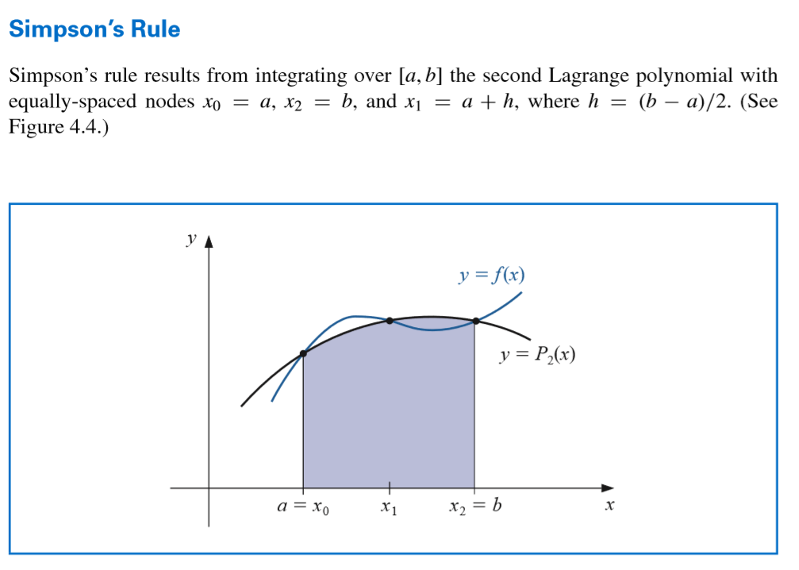

**Simpson’s Rule – Code in python:**

def Simpson(f, a, b, n):  
 h = (b - a) / n  
 k = 0.0  
 x = a + h  
 for i in range(1, n // 2 + 1):  
 k += 4 * f(x)  
 x += 2 * h  
 # print((h / 3) * (f(a) + f(b) + k))  
  
 x = a + 2 * h  
 for i in range(1, n // 2):  
 k += 2 * f(x)  
 x += 2 * h  
 print((h / 3) * (f(a) + f(b) + k))  
 return (h / 3) * (f(a) + f(b) + k)  
  
  
print(Simpson(lambda x: -x ** 2 + 10 * x - 16, 2, 8, 20))

**Function example: -x^2 +10x -16**

**F – function**

**A – Left-end range**

**B – Right-end range**

**N - number of Intervals**

**Results of code : 24.768000000000008**

**25.92000000000001**

**27.43200000000001**

**29.160000000000007**

**30.960000000000004**

**32.68800000000001**

**34.20000000000001**

**35.352000000000004**

**36.00000000000001**

**36.00000000000001**

